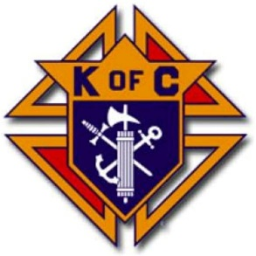

July 2019

Dear Community Member,

On Sunday, August 25th, High Peaks Hospice and Knights of Columbus councils throughout the North Country, will join together to hold their First Annual Silent Auction fundraiser. The Silent ‘Knight’ Auction
at the Knights of Columbus Hall, 4253 Main Street, Port Henry, from 9am-2pm. This event is being spearheaded by a former Hospice patient. His discharge represents a rare occurrence for the folks we care for. Please help us support his efforts to “give back”.

All proceeds will benefit High Peaks Hospice, your local non-profit organization dedicated to providing compassionate, professional healthcare for the terminally ill and their families for over 30 years. We would be honored if you would help us achieve our ambitious goal of $5,000 by supporting this event with a donation of an auction item. In acknowledgement of your generosity, we will recognize your contribution in our advertising and during the auction itself. Please also consider joining us on August 25th, and bring a friend!

By partnering with us, your gift will benefit patients and caregivers from your community at a time that they are most in need. To participate in the Silent ‘Knight’ Auction, kindly fill out and return the enclosed Business Participation Form. Please return it via email, or the High Peaks Hospice office by fax, or USPS.
We can help arrange for pickup of donated items. Feel free to contact me if you have any questions.

With gratitude for your consideration,

Kathy Schoolcraft
Volunteer Coordinator Mineville Office

High Peaks Hospice
PO Box 205, 47 Tom Phelps Lane
Mineville, NY 12956

Phone: 518-891-0606, ext. 724
Fax: 518-942-6513
Email: kschoolcraft@highpeakshospice.org

High Peaks Hospice provides end of life care that
listens with respect, cares with compassion, supports with choice,
and comforts with understanding wherever you call home.
For more information call 518.891.0606
visit our website at highpeakshospice.org.

High Peaks Hospice & Palliative Care is a 501C3 not-for-profit organization.
Fed Tax ID #14-1712904 NYS Charities Registration #04-48-44

